Title of Your Talk or Poster

Givenname1 Familyname1¹, and Givenname2 Familyname2^{1,2}, Givenname3 Familyname3³

¹ Department of Physics, Some University, City, Country
² Institute for Computational Physics, City, Country
³ Department of Chemistry, University of Somewhere, City, Country

Write the main text here. The length should be one page at maximum. Generate a PDF file and upload it to the online registration website.

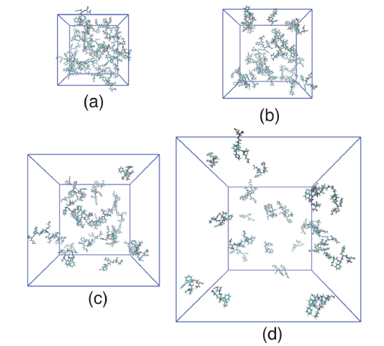
Figure 1: Figure caption.
References
[1] A. Author1, B. Author2, and C. Author3, Phys. Rev. Lett. 34, 12345 (2023).

